

** Summer Holiday Homework 2025-26**

**Class-II**

**Subject**-**English**

Q-1. Complete the following worksheets in your holiday homework **(Fun with Learning)**book.

1. Worksheet - 1 - Name game
2. Worksheet - 2 – Rhyming wards
3. Worksheet - 3 – Naming wards
4. Worksheet - 4 – Puzzle Time, Special names.
5. Worksheet - 13 - Is and are

Q-2.Book reading from pg. no 41 to 54.

Project/Assignment(Do any one)

Q-3. Make a model or chart on the following topics.

i. Types of Noun

ii.Use of preposition

iii.Parts of speech

Q-4.Learn and write the definitions of noun and pronoun with examples.

Q-5.Learn and write 2 new words daily along with their meanings.

Q-6.Improve your cursive writing skills through regular practice.

**Hindi**

1- आठ पंक्तियों की एक कविता लिखें और याद करे।-

2- प्रातःकाल के समय होने वाली गतिविधियों के बारे में लिखिए।

3- आप सर्दी से बचने के लिए क्या-क्या करते हैं? लिखिए।

4- हिंदी वर्ण माला के स्वर और व्यंजनों को अलग-अलग लिखकर याद करें |

5- प्रतिदिन 2 - पर्यायवाची शब्द व 2- विलोम शब्द याद करके लिखें |

6- प्रतिदिन अपनी पाठ्य पुस्तक का एक पेज पढ़कर सुलेख करें।

7- गाय पर 10 वाक्य लिखकर याद करें।

8- नीचे दी गयी वर्कशीट को अपनी हॉलिडे होमवर्क **(Fun with Learning)** बुक में कीजिए-

1. वर्कशीट –1, 3, 13, 14 - खेल – खेल में
2. वर्कशीट – 2, 6, 7 - वर्णो का ज्ञान

**Maths**

Q1.Complete the following worksheets in your holiday homework**(Fun with Learning)**  book.

1. Worksheets-1 Numbers
2. Worksheets-2 More Numbers
3. Worksheets-3 Number names
4. Worksheets-4 Addition on the number line
5. Worksheets-5 Add (1-20)
6. Worksheets-6 More Addition
7. Worksheets-7 Subtraction on number line
8. Worksheets-8 (How many)
9. Worksheets-9 Match
10. Worksheets-10 Fact families
11. Worksheets-24 Two-digit Addition/Subtraction
12. Worksheets-26 Addition/Subtraction

**\*\*Assignment\*\***

Q- 2.Write number names from one to one hundred(1-100)

Q-3. Make a model of Place value.

Q-4.Learn and write multiplication tables from 2 to 15 in your notebook.

Q-5. Draw picture and write name of 10 objects you find at your home which are long and round in shape(on chart)

**Subject-E.V.S**

Q1. Complete the following worksheets in your holiday homework**(Fun with Learning)** book.

i) Work Sheet-1 to 25

Q2.Write 8 lines about your family.

Activity Work-

1.Draw and colour a picture of internal or external organs on the chart paper.

2.Take a nature walk around your neighbourhood or near by park. Observe and collect leaves ,flower or other natural things.

**Subject**- **Computer**

Q-1. Complete the following worksheet in your holiday home work **(Fun with Learning)** book

i) Worksheet 1 – My computer

ii) Worksheet 2 – Parts of computer

Q2.What is computer?

Q3.Name the places where computer is used.

Project Work

Q-4. Prepare a model of any one input device of computer.

Q-5.Book Reading from page no 30 to 43.

**Subject-G.K.**

Q1.Write the name of any 5 juicy fruits.

Q2.Name 5 things that keep our surroundings clean.

Q3. Prepare a kite with the help of matchsticks and colour it (on chart paper)

Q4.Draw and colour a picture of national Flag.

Q5.Give the answer of the following.

(i)National Fruit of India. (ii)National Animal of India.

(iii)National Anthem of India. (iv)National Flower of India.

(v)National Tree of India.

Q-6.Learn and write 10 fruits and vegetables name and paste their picture also.

**Subject – Drawing**

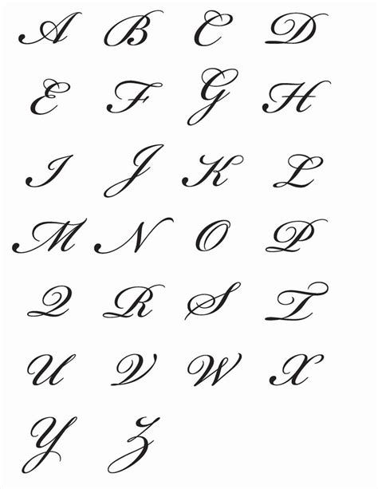Q- 1 "Practice writing A to Z calligraphy letters in your notebook with the help of given examples.

**Creativity corner :-**

**Prepare a Father’s day card, give it to your father and take a short video or pictures.**

1- Father' day Celebration on 15 June 2025

**Prepare a short video or take pictures related to any one activity**

1- Environmental day Celebration on 5 June 2025

2- Use any recyclable material like - plastic , bottle, cardboard boxes, old C.D and make any craft material

3- Reuse rain water

4- Plant any indoor or outdoor plant in your house

5- Any ecofriendly activity to save mother earth.

6- Implant Any seed in soil and observe its growth.

**Perform any one activity and prepare a short video or take some pictures.**

1- International Yoga dayCelebration on21 June 2025

2- Surya namaskar

3- Tadasana (Mountain Pose)

4- Vrksasana (Tree pose)

5- Bhujangasana (Cobra Pose)

6- Paschimottanasana (seated Forward bend)

**Note – (i) Revise the syllabus covered so far in every subject.**

**(ii) Use your subject notebook to solve question.**

**(iii) 5 marks will be awarded in each subject in Periodic test-II for completing the holiday homework.**